Sheffield Street Artwork - Self-walking tour

Welcome to the Give It A Go - Sheffield Street Artwork - Self-walking tour. Buckle up as you’ll discover some of the most amazing pieces of work from Pete McKee. This tour will take you approximately 1 hour.

Pete McKee is a born and bred Sheffielder and hugely popular artist in the steel city. His artwork is often a celebration of the North and the working classes. It’s always worth looking out for one of his fantastic exhibitions or heading over to Sharrow Vale Road to his gallery, A Month Of Sundays. While not primarily a street artist he has painted several large scale wall murals over the years; these murals are some of the most popular contributions to Sheffield’s street art scene. Pete is also a member of local ukelele band The Everly Pregnant Brothers and a part-time DJ.

Fancy listening to them on your tour. Here is their Spotify playlist - https://open.spotify.com/artist/1RykM0wTlufS2Z3Vneo5gS?si=mZnCd6RESYK2vs7NOdi2cQ

The Everly Pregnant Brothers were formed after a drunken dare by Pete Mckee and Richard Bailey. The success of the dare prompted the pair to draught in a bunch of disparate chaps who had three things in common, the love of beer, ukuleles and having a laugh.

Pete McKee
Website - https://www.petemckee.com/
Twitter - @PeteMcKee
Visit McKee Gallery - 365 Sharrow Vale Rd (former name - A Month Of Sundays)

- Muriel
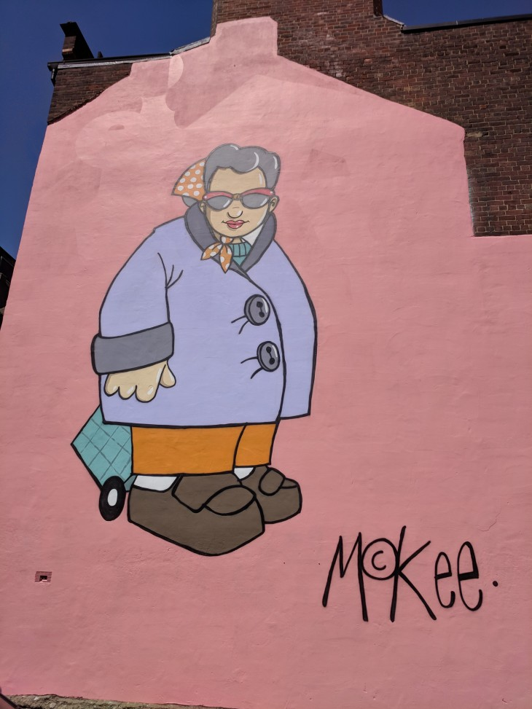
(Carver Street, S1 4FS)

Our tour starts on Carver Street.

We’ll start the tour with Muriel. You can find this cool painting just behind the Art House in the city centre.

Want to see how it was painted? Check out the video - https://www.youtube.com/watch?v=i6SHLm2SP1g&feature=emb_logo&ab_channel=PeteMcKee

The painting was completed in one, very hot day. The character Muriel smiles down on passersbys, surrounded by a warm pink, which references Pete’s original painting shown at the 'THIS CLASS WORKS' exhibition. Typical of the artist, Pete often writes accompanying text for his paintings.
'She’s never seen without her trolley or searching for that bargain. She has standards, though. It may be cheap but the stitching’s got to be right. She doesn’t mind a bit o’ fat but she doesn’t want it all gristle. Those neighbours have got new curtains but she knows where they could have got ’em cheaper. A tail-end of a bit of finny will do the job just nicely – no bones to worry about. That new shop’s just opened – I hear you can get stuff for just a pound. But first, I’ll pop into Heart Foundation and see if they’ve got a nice table lamp.’

- The Snog
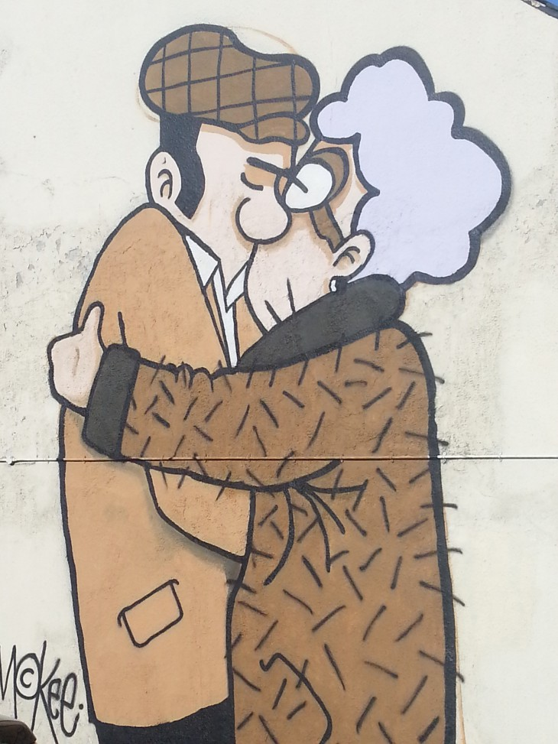(69 Broad Lane, S1 4BS)

Facing the back of the Art House on Carver Street, go left towards Trippet Lane. Then, turn left and take a quick right on Bailey Lane until you reach Broad Lane and you’ll find Fagans pub on the corner.

Pete’ large mural is painted onto the wall of Fagans pub on Broad Lane. This is one of the most iconic examples of street artwork around Sheffield.

Want to see how it was painted? Check out the video -
https://www.youtube.com/watch?v=VEieshZdNns&feature=emb_logo&ab_channel=PeteMcKee

The Snog was painted in 2013 and it has become a popular site for couples and newlyweds to have their photograph taken. His first ever mural, Pete never anticipated just how popular this image would become. However, despite being so well known, not many people are aware of the story behind this work of art. Originally, this mural was painted as a promotional piece for Pete’s 2013 exhibition The Joy of Sheff. A play on words, the exhibition referenced the famous book title, The Joy of Sex. The Snog mural was an extension of this humorous reference as the embracing elderly couple are based on The Joy of Sex’s iconic front cover which originally featured a kissing couple in a state of undress.

- Frank the Whippet
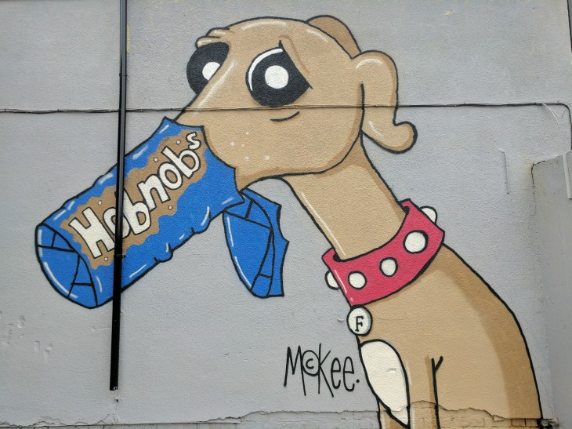(92 Burton Road, S3 8DA)

If you are up for a bit of a walk, facing Fagans pub, go left and follow Broad Lane until you reach the National Emergency Services Museum. At the roundabout, turn left on Gibraltar Street, then another left on Allen Street. Cross Moorfield (A61) and continue going left until the next roundabout. When you see UniHomes, turn right on Cornish Street, then right on Green Lane. Once you turn left on Ball Street, cross the bridge and continue until you reach Burton Road. Turn left on Burton Road and you will soon find Frank.

The mural covers one of the walls of Kelham Arcade (92 Burton Road), and is visible from the road.

Pete Mckee's mural of Frank the Whippet was painted in 2016 for the Feature Walls Festival. The painting is part of Pete's exhibition "This Class Works" from July 2018.

Since you are already in the area, you can also visit Shalesmoor Street in Kelham Island where there are loads of nice cafes to try such as The Grind Cafe, The Works and Gaard Coffee Hide (make sure to check opening hours).

